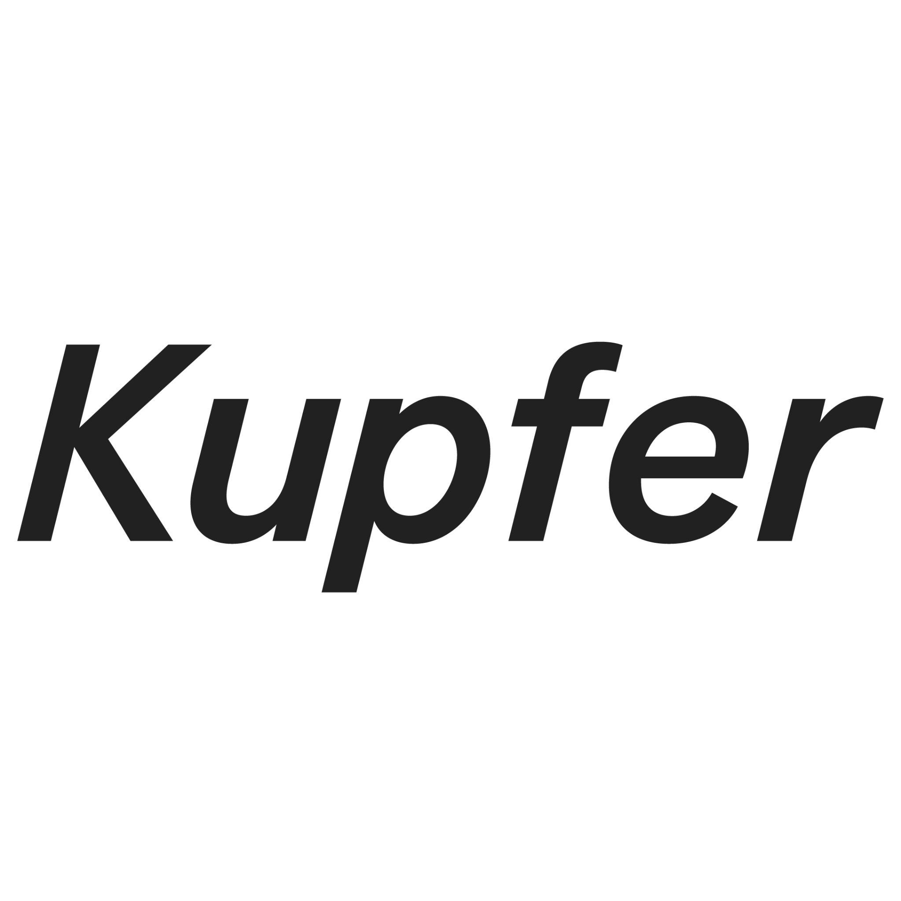
If I Were You
Asafe Ghalib, Cibelle Cavalli Bastos, Elvis Almeida, Enorê, Mariana Mauricio, Pauline Batista, Rafael D’Alo, Rafael Pérez Evans, and Zé Tepedino
Curated by Rafael D’Aló
28 May - 18 June 2022
Kupfer
Monday - Friday: 10am- 6pm
Saturday: 2pm - 6pm

The bridge descends as [though] from the cosmos under the revelry-sound of trains that run from the hillsides to the ocean of the Central Station; I know not why the shadows below are shadows of what I feel
Hélio Oiticica, 1969

Rio de Janeiro, a city machine running on sweat.
People melting in pleasure.
People melting in pain.
If I Were You features the work of nine artists whose trajectories have been touched by Rio and who have experienced the swelter of the city as material. This group exhibition, curated by artist Rafael D’Aló, explores how the influence of a place can be both yearned for and inescapable.
Rio stands firmly in the world’s pantheon of emblematic cities. The heat, the sweat, the sand, the sea, the thong, have all come to symbolize its wide appeal. The works presented here are meditations on self-image, freedom and ambivalence. They are exercises in recontextualizing the collective imagination, as well as interruptions in the ongoing flow of prescribed images associated with the city.
The affinities between the exhibited artworks are tentative rather than fixed. Some are investigations on the cumulative nature and power of identity – such as in Enorê’s 3D printed ceramics, where the artist lends their own face to multiplication; in Asafe Ghalib’s statuesque portraits of his LGBTQIA+ community; in Cibelle Cavalli Bastos’ half curvaceous/half blurred bestialy familiar creature trying to seduce us; or in Zé Tepedino’s indistinguishable family portraits. Others play with reconfiguration – such as Rafael D’Aló’s record of an incidental sculpture and Elvis Almeida’s colourful forays into the abstract canon. Elsewhere in the room, Rafael Pérez Evans’ orchid de/re-territorialises a pile of potatoes, whilst Mariana Maurício delves into the mundane and the desirous that coexist within ourselves, and Pauline Batista’s transpiring slime balls raise questions about the commodification of the reproductive body.
If I Were You is simultaneously a celebration and a critical examination of the poetic power of a place. Both the allure of a place and the stain of a place. Ghalib’s Vidigal (2017) gives us the only image of Rio in the show. A rare panoramic vista of the Cagarras Islands from Morro do Vidigal. As our eyes move from the hillside to the ocean, the iconic carioca beaches, some of the most expensive real estate on the planet, are nowhere in sight.
About the artists
Asafe Ghalib is a Brazilian Queer image-maker and activist, based in London, who produces visual content for the LGBTQIA+ community. They have a belief in creating opportunities for people to express themselves authentically through photography in pursuit of equal rights by sharing different perspectives on gender and race. Asafe works in collaboration with people and communities to create their projects.
Asafe was one of the winners and the Story cover for British Journal of Photography “Ones to Watch” from 2021 and recently was selected by Creative Review as one of the photographers that have made an impact over the past 12 months as their Zeitgeist winners.

Mx. Cibelle Cavalli Bastos is an artist, musician, independent researcher, educator, and activist.They live and work in Berlin. Their inter-platform and transdisciplinary practice as research engages with the changing conceptualization of identity and performativity, pictorial communication, creative labor, and the propagation of behavioural patterns in the digital age.
They released four music albums worldwide under "Cibelle" for Crammed Discs and has performed and presented work in Martin Gropius Bau (Berlin-DE), ICA (London-UK), MASP (São Paulo-BR) Carnegie Hall (NY-USA), LCCA (Riga-LV), CAC Wifredo Lam (Havana-Cuba), Steirischer Herbst ( Graz-Austria), MdbK Leipzig (DE), Transmediale/Haus der Kulture der Welt (DE), KW Institute for Contemporary Art (DE), Fotomuseum Winterthur (CH), NRW-Forum Dusseldorf (DE) and collaborations within the 28th /31st São Paulo Biennial (SP-BR) alongside Yonamine and Tiago Borges, and as a member of assume vivid astro focus (AVAF).

Elvis Almeida was born in 1985 in Rio de Janeiro, where he lives and works. He has a degree in Engraving at UFRJ (2013) and attended courses on silk-screening at EAV Parque Lage and Art History at Redes da Maré, both in Rio de Janeiro. His solo exhibitions include: Estrada nebulosa sem olhos de gato, Galeria Mercedes Viegas (Rio de Janeiro, 2019); Revelação durante o nascimento de uma gota, Paço Imperial (Rio de Janeiro, 2018); O cotidiano das estruturas familiares, Projeto Tech Nô, Oi Futuro Flamengo (Rio de Janeiro, 2017); Certezas para dobrar, Mercedes Viegas Arte Contemporânea (Rio de Janeiro, 2016); Uma cidade de xapisco dividida por um muro de cau, Amarelonegro Arte Contemporânea (Rio de Janeiro, 2010).
Next October, Elvis Almeida will participate in the 20th Festival de Arte Contemporânea Sesc_Videobrasil (São Paulo).

enorê is a Brazilian multidisciplinary artist currently based in London and working with 3D printed ceramics, textile and video. Their work revolves around the fluidity of digital media into physicality and back, the modes of translation that arise from this kind of dynamics and how this relates to ways in which the body processes information. Using 3D scans and digital data to establish links between physical and digital realms, they bring into physical existence elements which can normally only be mediated through digital technology. They have recently exhibited with Bloomberg New Contemporaries and been commissioned by Contemporary And to create a new video series.

Mariana Mauricio was born in Rio de Janeiro, Brazil and lives and works in London. Her work has been in various individual and group exhibitions and is part of collections worldwide such as Estrellita and Daniel Brodsky and BGA Brazilian Golden Art. She holds a Masters in Fine Arts from Goldsmiths, University of London.
Encountering, collecting and assembling drives Mariana Mauricio's work. Some combinations are held by structures (often fabricated) and talk about eroticism, parenthood, the domestic, the body and our collective sensations within a place on a map or a route. With the aim to exhaust a found object and its embedded history, Mariana deconstructs and learns how to construct it again - touching on ideas of labour, expatriation and the meaning of home.

Pauline Batista (b.1988 Rio de Janeiro, BR) is a multimedia artist based in London. Her practice questions the impulse to render information and bodies transparent in the quest for ’the quantified self’. The artist creates her own networks that the viewers are invited to decode, through installations encompassing elements of photography, sculpture and sound frequencies. She graduated from USC with a degree in International Relations in 2010 and completed her MFA at Goldsmith University in London in 2017. Among recent solo and group shows, she exhibited at: Fondo (Turin, IT), Museo Civico G. Fattori (Livorno, IT), GALLLERIAPIÙ (Bologna, IT), Houston Center for Photography (Houston, USA), ATP Gallery (London, UK), University of Oxford (Oxford, UK), CADAF Digital Art Fair (New York, USA) and ARCO E-XHIBITIONS.

Rafael D’Aló studied film and fine art at the New School in NYC. In 2020 Rafael graduated with a MFA degree from Goldsmiths. He lives and works in London. His multidisciplinary practice is articulated through juxtaposing a wide variety of media. D’Alo’s works point towards consumerism in relation to the logistics of production and our ‘urbanised’ relationship with one another on a global scale.

Rafael Pérez Evans, Spanish – Welsh (b. Málaga 1983) lives and works between London & Spain. He received both an MFA & a BA in Fine Art from Goldsmiths College in London, in Autumn 2022 he will be reading for a practice-led Doctor of Philosophy in Fine Art at the University of Oxford funded by AHRC. His work has been exhibited internationally with solo exhibitions including Handful at The Henry Moore Institute, UK (2021), Pavo Realengo at Nogueras Blanchard Gallery, Barcelona (2017); Pararrayo at Abierto Theredoom Gallery, Madrid (2017). Two-person & group exhibitions include Thief, Invigilate at C3A Museum, Spain (2020); Salvation at Saatchi Gallery (2020); Unpacking, Wheels at South London Gallery & Leeds Art Gallery, UK (2019); The Devil’s Bird – Ornithomancy at Museum of Contemporary Art Taipei (2019); L’Dounne – Divination at Matadero, Madrid (2018) & Queima at Despina, Rio de Janeiro (2015).

Zé Tepedino (1990), lives and works in Rio de Janeiro. In 2016 he graduated in Visual Communication at PUC-Rio, and during his studies he approached the visual arts through classes with professors Cadu Felix and Eduardo Berliner. After School he becomes more and more involved with his practice and in 2018 he was baptized by the Igreja do Reino da Arte. His works has been increasingly turning his gaze to the city and creating works that expand questions and the scale of his poetics.
By carefully observing his surroundings, he chooses materials, colors, spaces, mostly banal situations, and through a thought that organizes himself by composing, he recombines these various items, creating new arrangements. Regardless of the media, he always understands his work as drawing and panting, whether in landscape with large installations or in monotypes on paper. For this, it makes use of different techniques, such as sewing, painting, sculpture, seeking to formalize ideas that always count.
with the process as co-author.It brings together different times and traditions, proposing a new look at the world around us.

Deleuze and Guattari, A Thousand Plateaus
Mark Fisher, Ghosts of My Life: Writings on Depression, Hauntology and Lost Futures
Guy Brett and Luciano Figueiredo, Oiticica in London

